# Header

Create part of Web Page like the following.

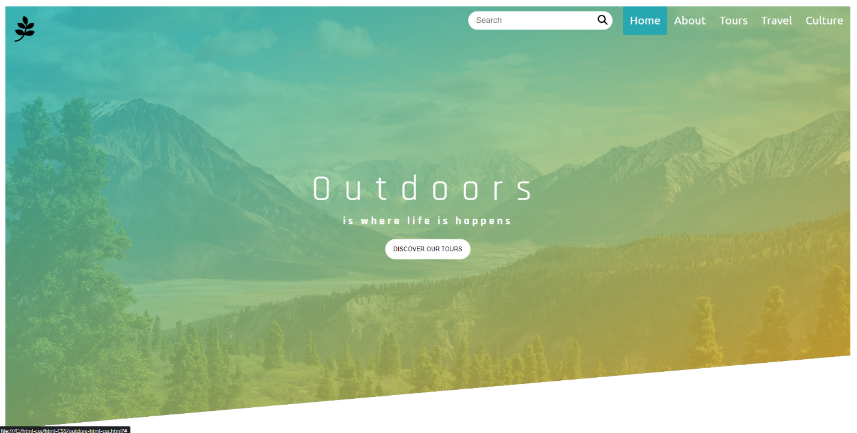

Hints

Use - header, section, nav, h1, button, ul, li, input, img

# Table

Create part of Web Page like the following.

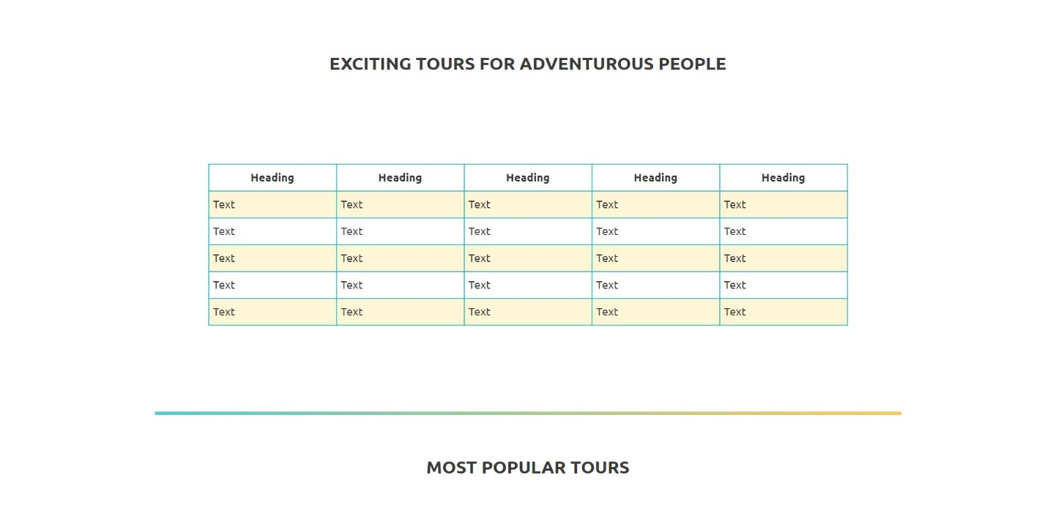

Hints

Use – main, section, h2, table, thead, tbody, tr, th, td, hr

# Card

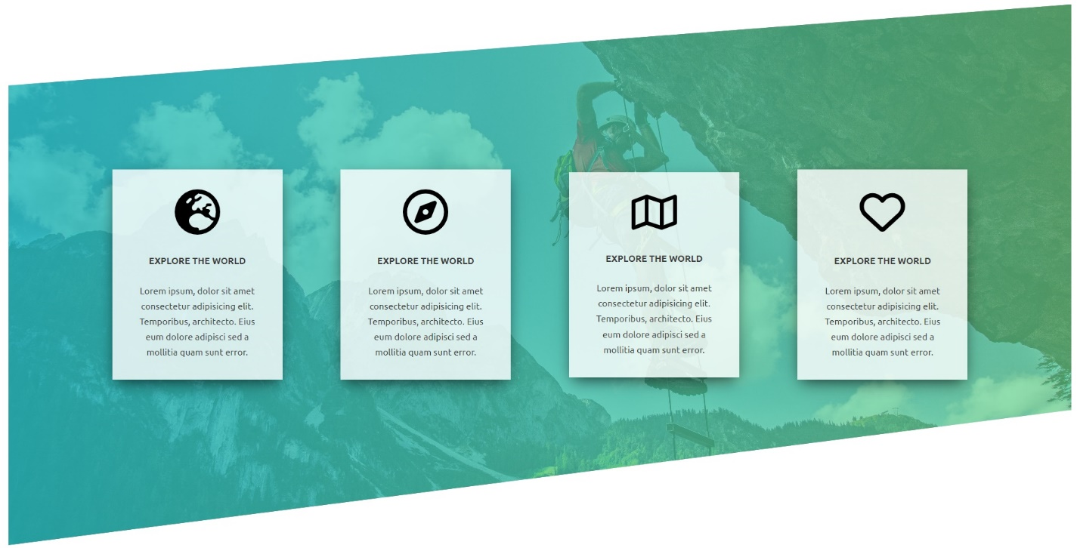

Hints

Use –section, article, img, h4, p